***Open Rocker Switch***

***Design Rationale***

Version 2.1

2022-June-14

**Version History**

|  |  |  |  |
| --- | --- | --- | --- |
| **Version #** | **Implemented** | **Revision Date** | **Note** |
| 0.1 | Gabriel Chiu | 2020-Nov-23 | Initial Draft |
| 2.0 | Jake McIvor | 2020-Dec-09 | Publishing Review |
| 2.1 | Tyler Fentie | 2022-June-14 | Minor Design Update |

MMC Design Specification Template Version: 2020-Apr-08

**Table of Contents**

Introduction 4

Background 4

Existing and Comparable Designs 4

Commercial Devices 4

DIY Alternatives 4

Version 1.0 5

Components 5

Assembly 6

Version 2.0 8

Objective 8

Ideation 8

Hinge 8

Flexures Hinges 8

Clip-on style Hinge 9

Top Piece 9

Return Mechanism 10

Prototyping 10

First Iteration 12

Final Design 13

Rocker Top 13

Rocker Bottom 14

3D Printed Hinge 15

Paddle Buttons 16

Divider 16

Tactile Switches 17

3.5 mm Mono Cable 17

Opportunities for Improvement 18

Appendix A: Reference 19

# Introduction

This document provides the design rationale for the Open Rocker Switch.

## Background

The Open Rocker Switch is an assistive switch that provides the user with two inputs. It is intended to be a functional replacement for the now discontinued Rocker Switch originally designed by TASH and provided by AbleNet. The switch is operated by depressing on either side of the device and provides users with the ability to interface two inputs to a device that accept a 3.5 mm jack. One of the original applications was for use as a Morse code input device.

# Existing and Comparable Designs

## Commercial Devices

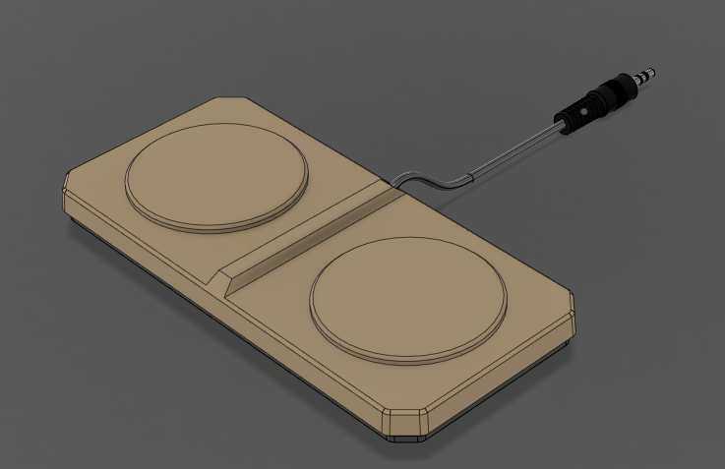

Figure 1 AbleNet Rocker Switch

There was only one device that were commercially available: The AbleNet Rocker Switch. The AbleNet Switch used a single stereo 3.5 mm cable to interface the two switches to any device that accepts it. The switch used a thermoformed plastic top, an acrylic base, and foam tape as the hinge to give the switch its ability to rock back and forth. The switches used were simple limit switches for a low activation force and smooth travel. The total cost of the switch was $110 USD off of AbleNet but it has now been discontinued from the website and is no longer available.

## DIY Alternatives

No comparable open-source or do-it-yourself (DIY) alternatives were located based on a search of Thingiverse and other sites, but it may be labeled as a different kind of switch than a rocker switch.

# Version 1.0

An initial design of the Open Rocker Switch was designed based on the dimensions of the original AbleNet Rocker Switch with the goal of manufacturing the switch using a 3D printer.

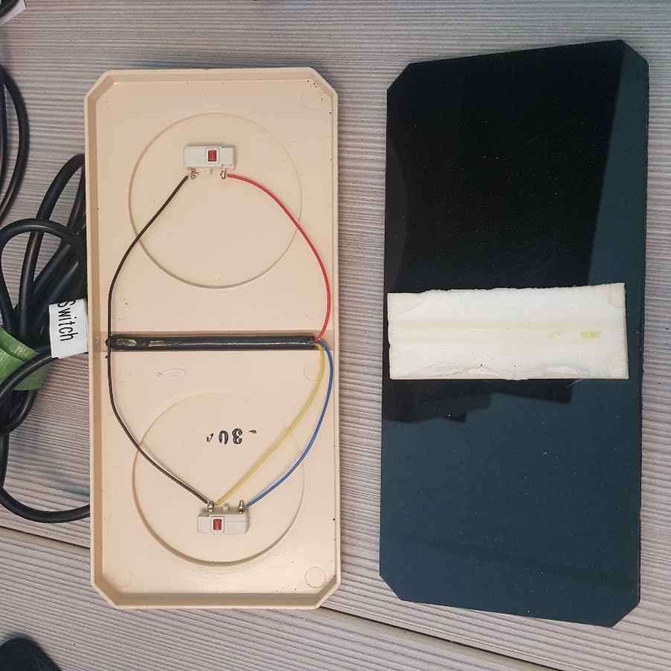

Figure 2 Original AbleNet Rocker Switch

Several changes were made to the original design. The non-stick foam and acrylic were combined into a single component for the base. The top of the switch was modified to accommodate a 12 mm tactile switch as the original limit switch was no longer available. The location of the switch was moved to provide a similar activation force to the original.

## Components

1 - 3D Printed Switch Top (~ 43 g of filament, $2.15, ~ 2.5 hrs)

1 - 3D Printed Switch Bottom (~ 43 g of filament, $2.15, ~2.5 hrs)

1 - 3.5 mm stereo cable (e.g. <https://www.digikey.ca/short/p4ft0w>, ~$5.20 OR try local dollar store)

2 - 12 mm tactile switch (e.g. Omron B3F-5050,<https://www.digikey.com/short/jvzq2d>, ~$1.90)

1 - 3D Printed 12 mm switch soldering jig (Optional; ~5.0 g of filament, $0.25)

Double sided tape

## Assembly

Once the support material was removed from the top, the 3.5 mm cable is threaded through the hole. The wires are stripped and soldered to the individual switches. The wiring for the stereo jack was chosen to match that of the AbleNet Rocker Switch. The right side (looking down, with cable out the back, is wired from sleeve to ring. The left side is wired from tip to sleeve.

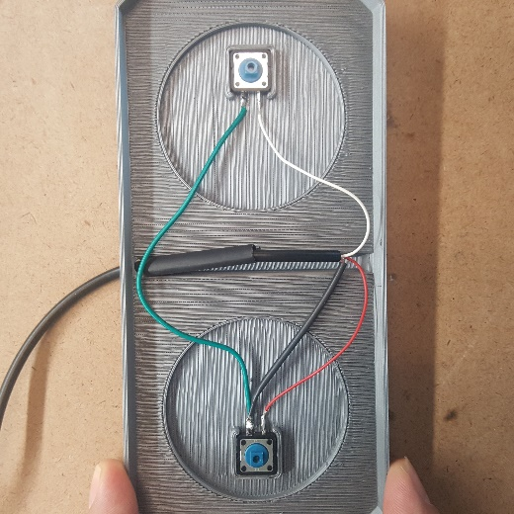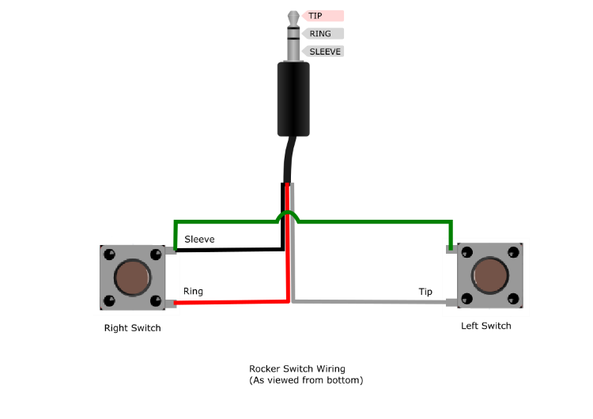

Three layers of double sided tape are stacked and attached to the top and then positioned on the base.

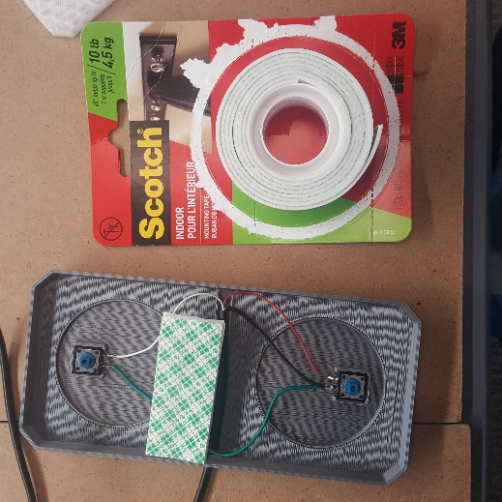

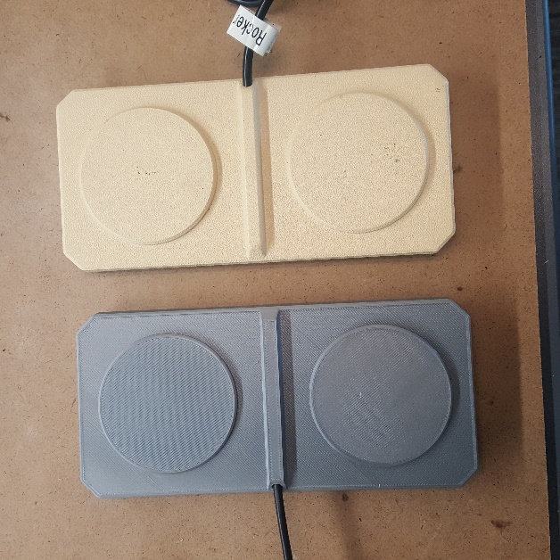

Figure 3: Switch Comparison.

Figure 3 illustrates the final switch on the left and the original AbleNet Rocker Switch on the right.

# Version 2.0

## Objective

The objective of version 2.0 was to optimize the design for 3D printing, change from a stereo cable to two mono cables, replace the foam tape hinge to something easier to assemble, and improve the strain relief of the cable. Additional customization options were also included.

## Ideation

This section will go through some of the ideation for the design changes in version 2.

### Hinge

First is the Hinge. The hinge was one of the two big factors in the design change and was the more complicated piece to solve. And a couple of ideas were considered.

### Flexures Hinges

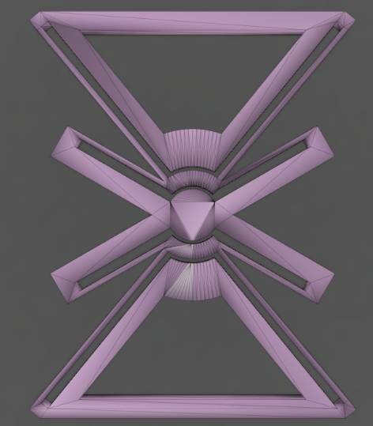 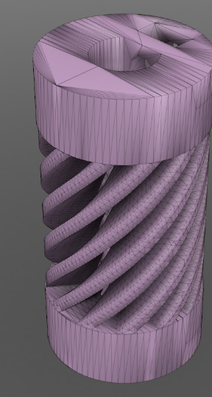

Figure 4 Butterfly Flexure and flexible coupling

The first idea was the use of plastic 3D printed flexures. Switches like the MMC60 use a plastic flexure as both an actuation system and a return spring. Therefore, with the Rocker switch needing the same requirement, a plastic flexure was considered.

### Clip-on style Hinge

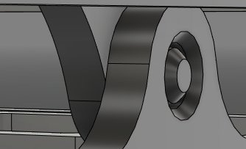

Figure 5 Through Hole Clip on Hinge

The second idea for a hinge design was a clip-on style hinge. This is a 3D printed hole and pin which would slot into each other to both assemble the top and bottom pieces of the switch and give the switch its ability to rotate. One issue was the method of returning the system to its neutral position.

### Top Piece

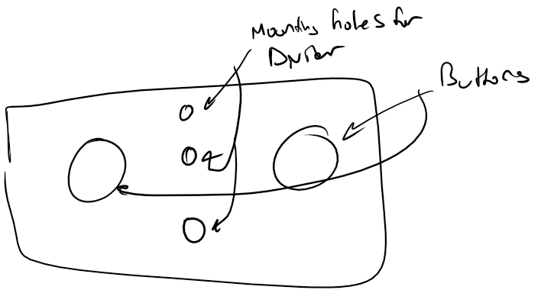 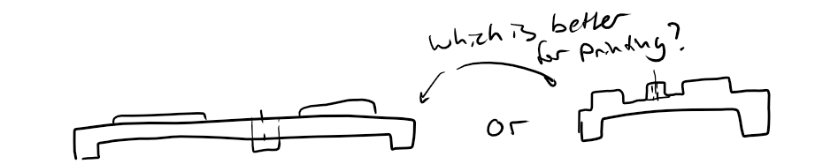

Figure 6 Top Piece Ideation

The top piece’s first ideation was a simple idea with two bumps to symbolize the buttons, and 3 mount holes on the top for the Divider.

### Return Mechanism

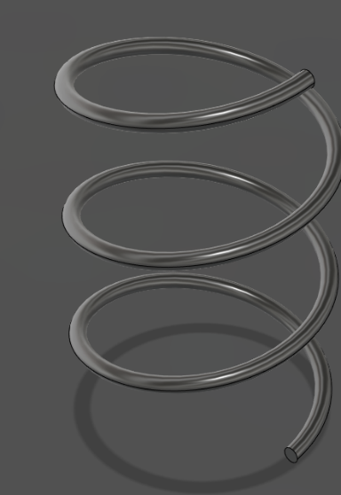

Figure 7 LipSync Spring

To solve the issue with returning the system to neutral, LipSync springs were considered given their small height and the strength they have to push the system back to its original position.

# Version 2.1

## Objective

The objective of version 2.1 was to resolve the issue of the rocker switch staying depressed on one side after a button is pressed. This was found to be caused by some 3D prints of the pin components being uneven and the gluing method being inconsistent. The goal of this design was to remove the need for gluing pins by altering the button design.

## Result

This update did not require ideation but rather just a simple fix. Since the pins were no longer in the design the buttons needed to be able to press the tactile switches themselves. The photo below shoes the difference between version 2.0 and 2.1.

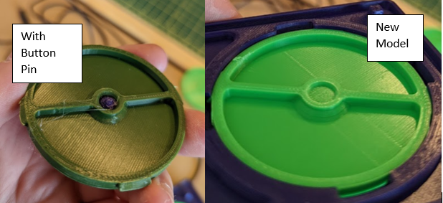

V2.1

V2.0

Below are photos of the version 2.1 and 2.0 buttons. The version 2.1 buttons filled in the pocket that was left for the buttons. This was an extruded cylindrical feature with the same diameter and 2 mm of height.

V2.1

V2.0

The documentation and design files were also updated to include these changes.

## Prototyping

### First Iteration

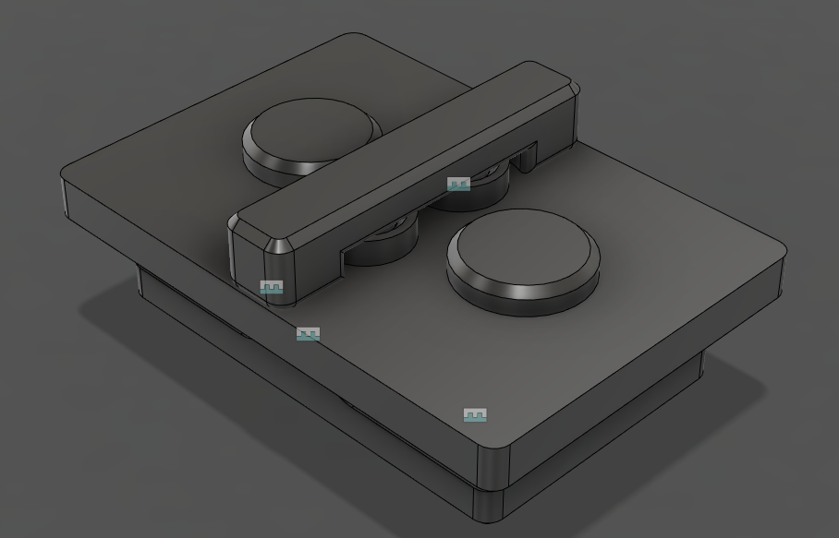

Figure 8 First Iteration

The first iteration used some features shown in the ideation section. As seen the top piece ideation was used, and the clip-on axle and springs were used in this iteration. The reason that the Clip-on axle design is used is that with the plastic flexures, the system bends too far and would cause permanent deformation to the plastic flexures and the plastic flexures needed too much tweaking for them to be usable. This version is a miniature scaled version of the final product to allow for the testing of ideas and tweaking.

The top piece design still required support to print which was not desirable because it would use too much material when scaled up to the full version. Therefore, in the final design the switch’s top piece is changed so that the divider piece and the buttons are separate prints that can be mounted to the switch.

The Clip-on Axle design worked very well in the first iteration and was close to being chosen as the main method of rotation. However, when the design was upscaled the design had issues with the axle piece breaking when assembling so the design is changed in the final design.

The final piece that was taken was the springs to return the system back to neutral. However, the springs made the switch too tall which didn’t fit with the objective of keeping the switch the same form factor as the AbleNet switch. Therefore, the springs are net kept in the final design and the switches’ internal spring will be used to return the system to neutral.

## Final Design

## Rocker Top

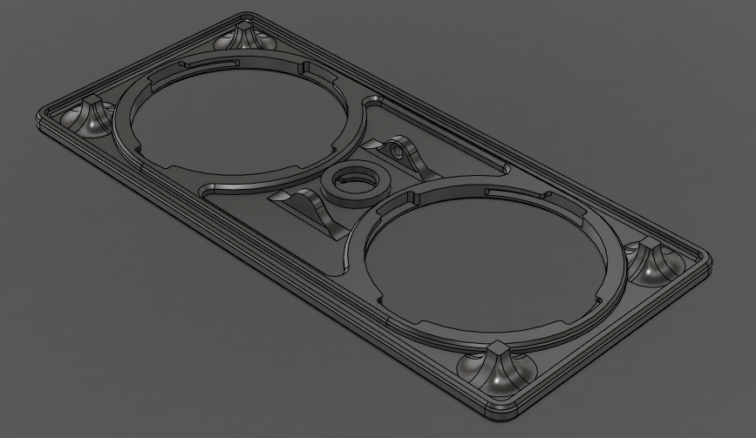

Figure 9 Rocker Top

The top piece of the rocker was designed to mount the customizable divider and paddle button pieces. The top piece also has 4 hardpoints that act as hard stops so the switch will not bottom out on the tactile switch and possibly break the tactile switch. A couple of ridges are designed into the switch as seen in the figure to add a little bit of rigidity to the structure. There was some issue with the PLA piece flexing too much and causing some light deformation.

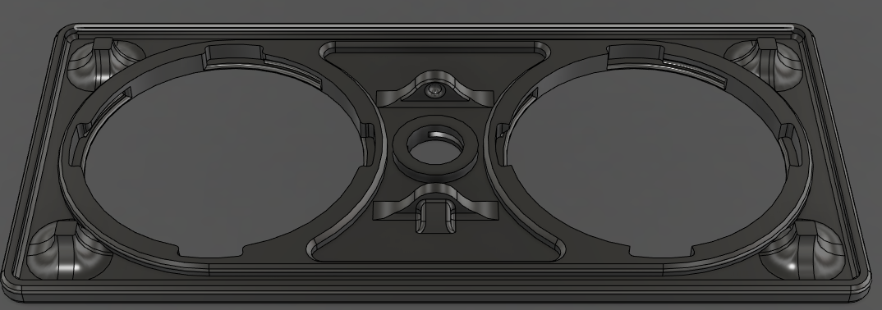

Figure 10 Top Piece Changed

Another issue that was a concern, more for the builder than the designer, was that the top piece had different turning directions for the customizable button pieces and the divider was to turn counterclockwise to secure. The team wished to have a standard turning direction similar to that of tightening a right-handed threaded screw where clockwise is to tighten and counter-clockwise is to loosen and take off the pieces.

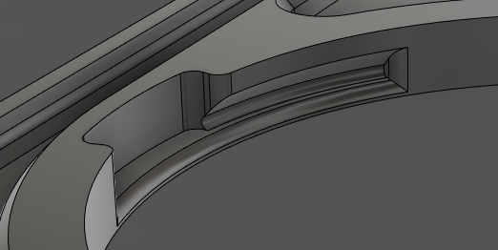

Figure 11 Changed Slot shape

Another change to the top piece is the key slots. The original slots were simple cut outs in the piece which required support to properly print. However, getting the support material out of the slots was near impossible and required too much work to get the support out. So the slots were changed with a slanted slot so the need for support is not needed anymore.

## Rocker Bottom

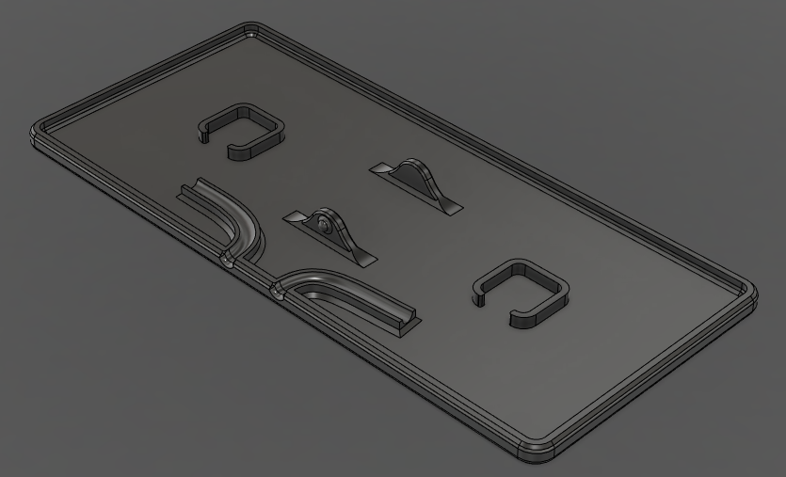

Figure 12 Rocker Bottom

The bottom piece is where the two tactile switches and cables are mounted. The cable tracks are bent to act as a small strain relief and the exit of the tracks are rounded to account for bending of the wire during operation.

## 3D Printed Hinge

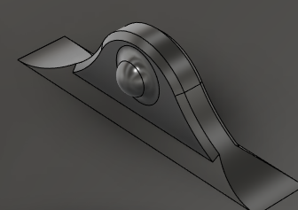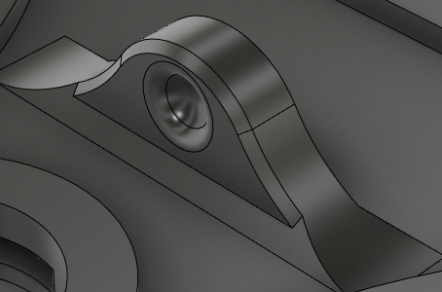

Figure 13 Axle Design

The axles use a ball and socket design. Initially the axles used a more pin and hole axle design, but that design required the axle features to bend too much and would break on assembly. The inspiration for this type of design is from the snap fit features from the simple switch tester designed by Birk Zukowsky. This design minimized the need to bend the axle features and gives the axle a longer life cycle if the top piece is repeatedly taken off and put on.

The spacing of the axle is 15 mm from the center. This was a more arbitrary spacing to account for a good enough spacing between features on the top piece. A wider spacing was tested which did not pass because the switch could be depressed if pressed in the middle which was undesired.

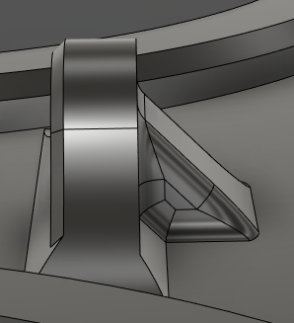

Figure 14 Axle Support Addition

The top piece was updated during the final stages of development because the axle pieces on the top piece kept on breaking when assembling. A simple rib feature was added to the back of the top axle piece as a support. This takes away some ease to the assembly but gives the piece rigidity to prevent the piece from breaking anymore.

## Paddle Buttons

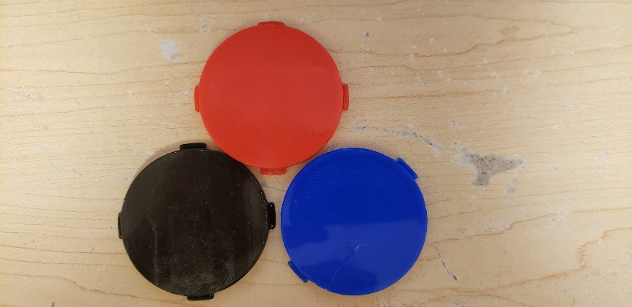

Figure 15 Paddle Buttons

The paddle buttons are one of the two pieces that can be customized by the user. Whether it is a custom logo on the button, or a different colour, the buttons can be customized by the user to suit their requirements for the switch.

## Divider

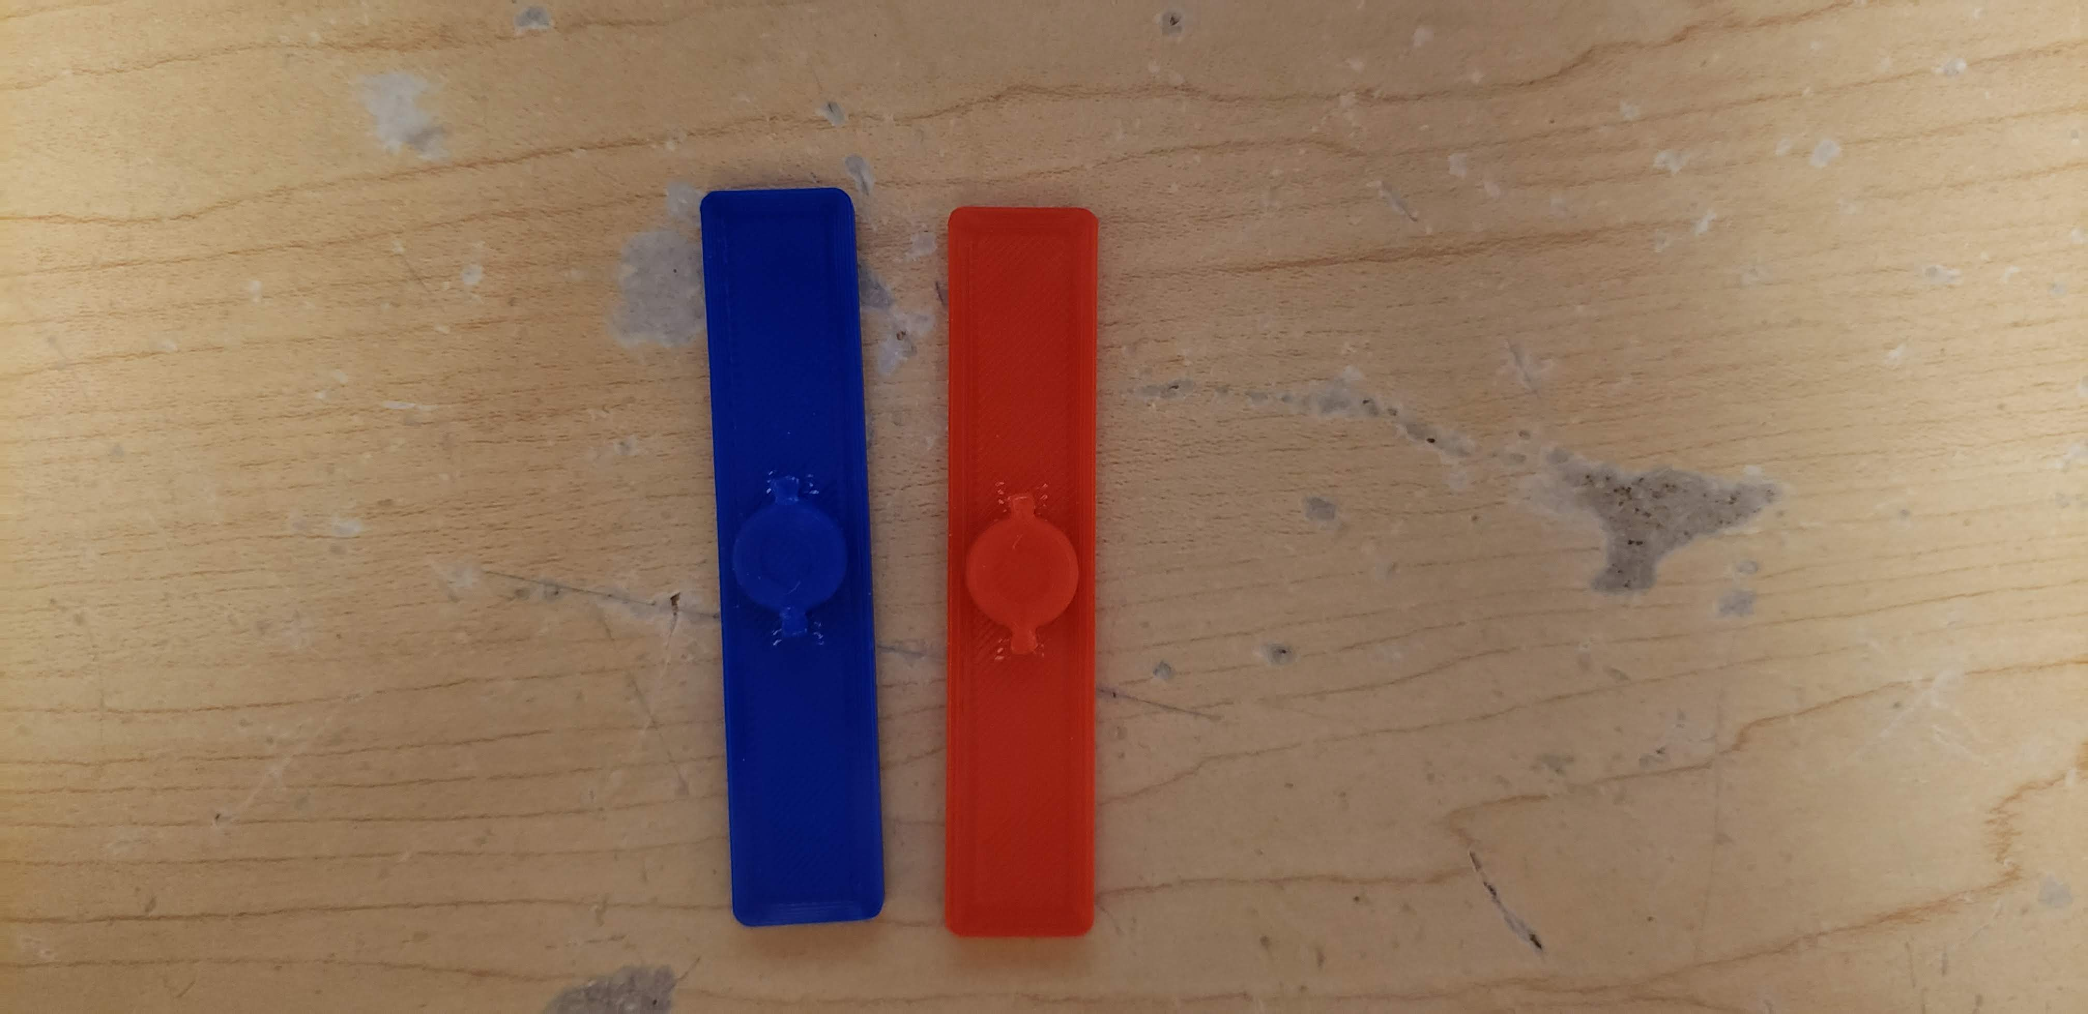

Figure 16 Divider Pieces

The customizability of the divider is more extra features on the device. There is not a lot of room for custom logos, but it can be possible to put a custom logo that would fit to personalize the switch for the user.

## Tactile Switches

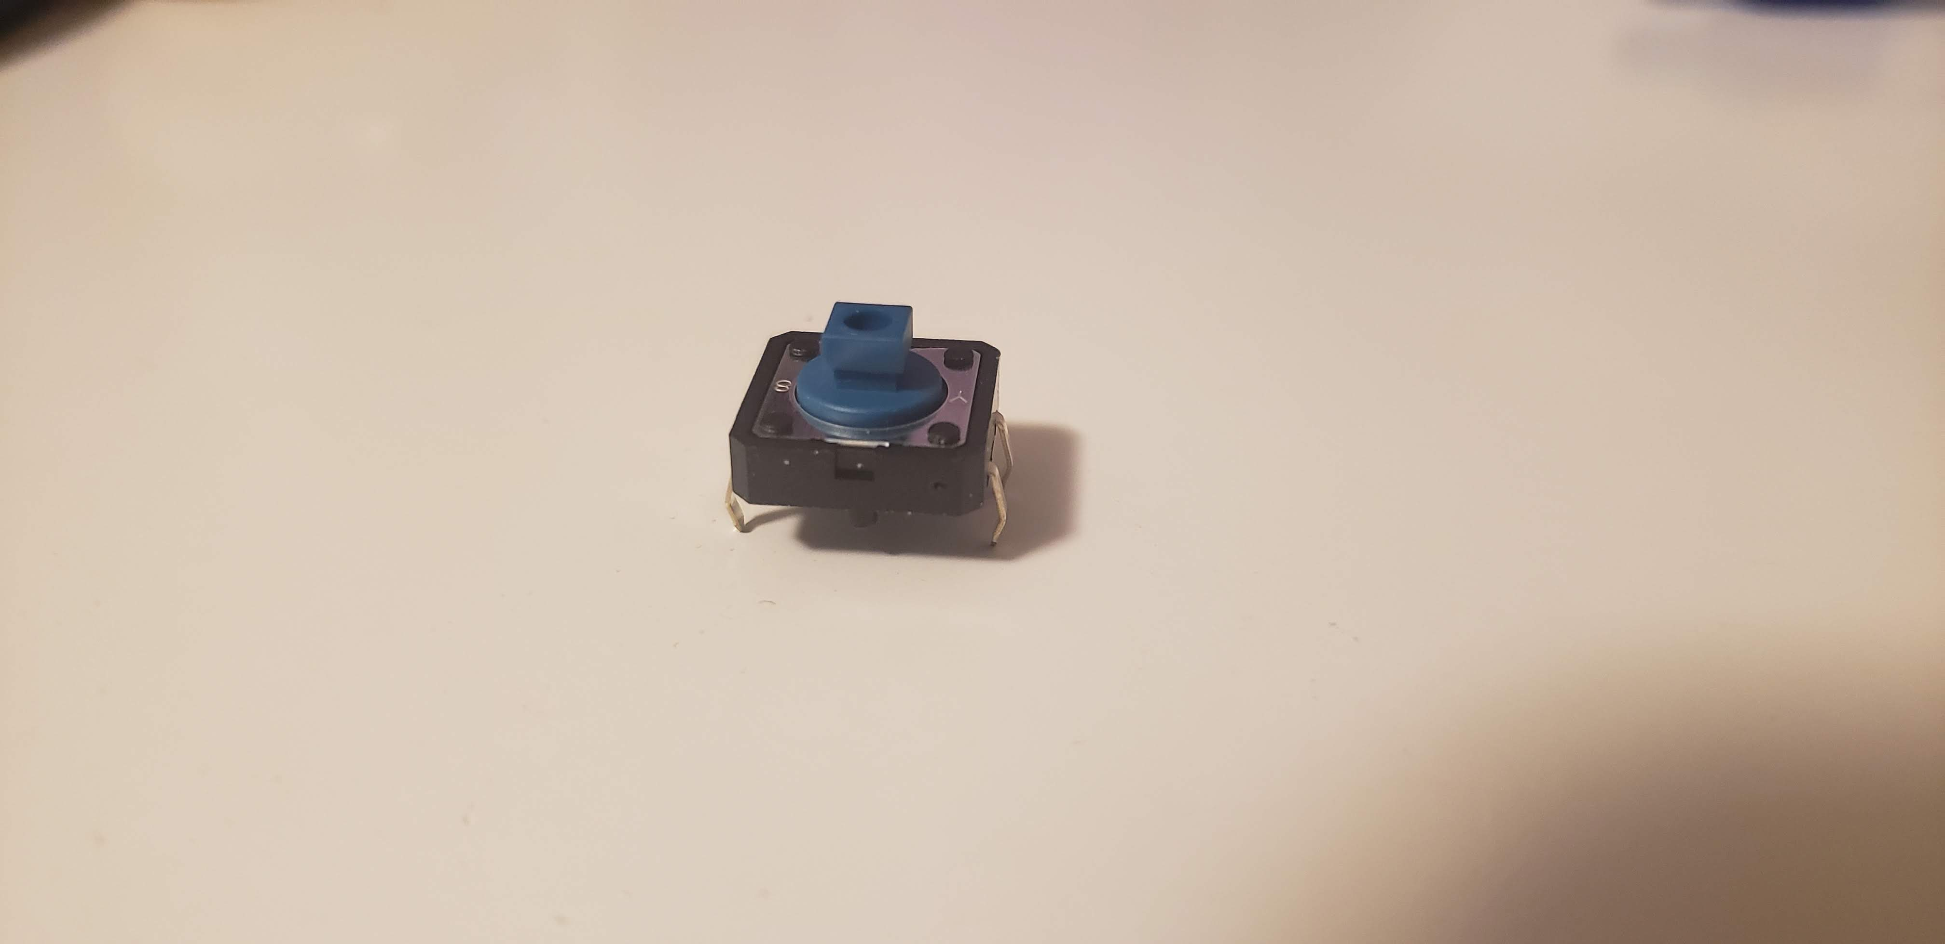

Figure 17 BF-5050 Tactile Switch

The switch used for the Rocker switch is the Omron BF-5050 tactile switch. This switch is used in many of the other MMC switches like the Light touch switch or the Raindrop switch. For more information on the switch. Refer to Datasheet [1].

## 3.5 mm Mono Cable

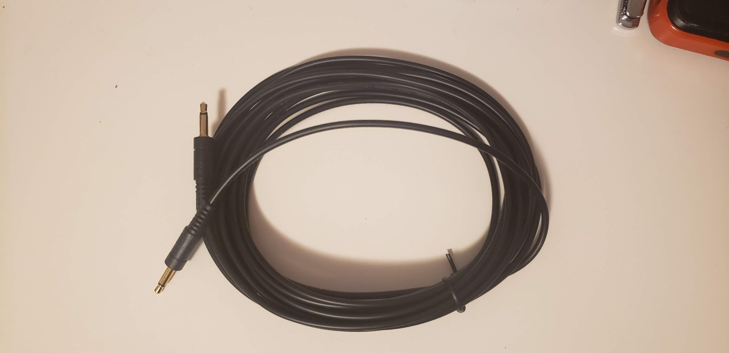

Figure 18 3.5mm Mono Cable

A normal 3.5 mm Mono Cable used to connect the switch to any device. The cable is split in half so one cable can interface the two tactile switches. Two mono cables are used instead of a stereo cable because most of the devices which the community uses, have 3.5 mm plugs as their interface.

# Opportunities for Improvement

High to low Priority:

* Improve Button Pin design to allow for testing different heights before permanent mounting to accommodate for printing differences
* Improve cable strain relief
* Improve cable track for better gluing
  + Not necessary but can be changed by user to match cable that they have
* Have a Bluetooth attachment to make the switch Bluetooth
  + Can work with the Lipsync to have two extra buttons for the Lipsync
* Improve on the fit for Keyed design for better locking

# Appendix A: Reference

[1] Omron B3F-5050 Data Sheet

<https://4donline.ihs.com/images/VipMasterIC/IC/OMRN/OMRN-S-A0001309768/OMRN-S-A0001309768-1.pdf?hkey=52A5661711E402568146F3353EA87419>